Unit 5: Energy/The Transfer of Energy between the Sun, Earth’s Surface and our Atmosphere
Name:______________________________ Block:____________ Date:________________
Where Does Earth’s Energy Come From?
- The temperature measured at Earth’s ____________________(+6000 C) is actually inferred to be _______________ than the _________________(~5600 C). This heat is largely due to the initial heat created from the _______________________(accretion/impacts).
- MOST of Earth’s energy received at the __________________ is in the form of ___________________ _______________________created by the Sun (ESRT pg. 14)
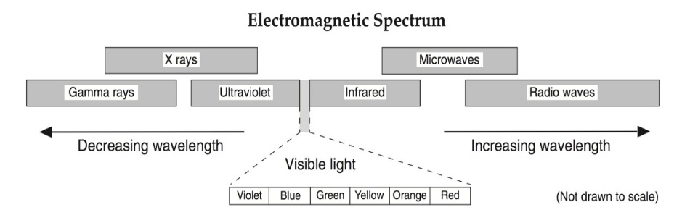
  - Earth’s magnetosphere and atmosphere filter out most of the high energy, short wavelength radiation (x-rays, gamma rays and most UV)
  - Energy that makes it to Earth’s surface is in the form of:
    - Visible (ROYGBV) 44%
    - Infrared (Heat) 48%
    - Ultra Violet (UV) 7%
Radiation: when energy is transferred through____________________________________; requires no ___________________ and can be transferred through _________________________ of matter.
How much energy can be ____________________________by Earth’s surface depends on a few factors:
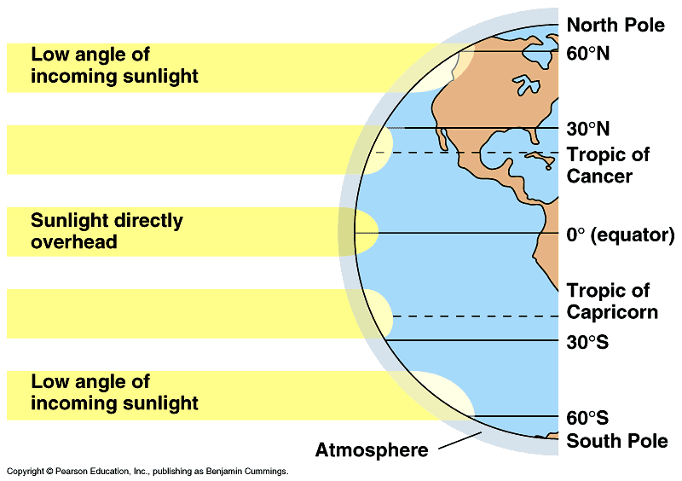
- The Angle of Insolation (sun’s angle): __________________________________________________
(Measured from the horizon)

Because the earth’s surface is ___________________, all latitudes receive ___________________ angles of insolation. The ________________ the angle of insolation, the__________________ energy absorbed by earth’s surface.
- The type of surface receiving the energy; __________________________________________________________
Color
- _________________________colored material will naturally absorb ________ solar energy compared to lighter material, but they will also cool down ___________.
Example:
Texture
- __________________________or _______________ of a surface affects the amount of energy absorbed. The______________________ a surface, the ___________energy it will absorb and the _______ it will reflect.
Example:
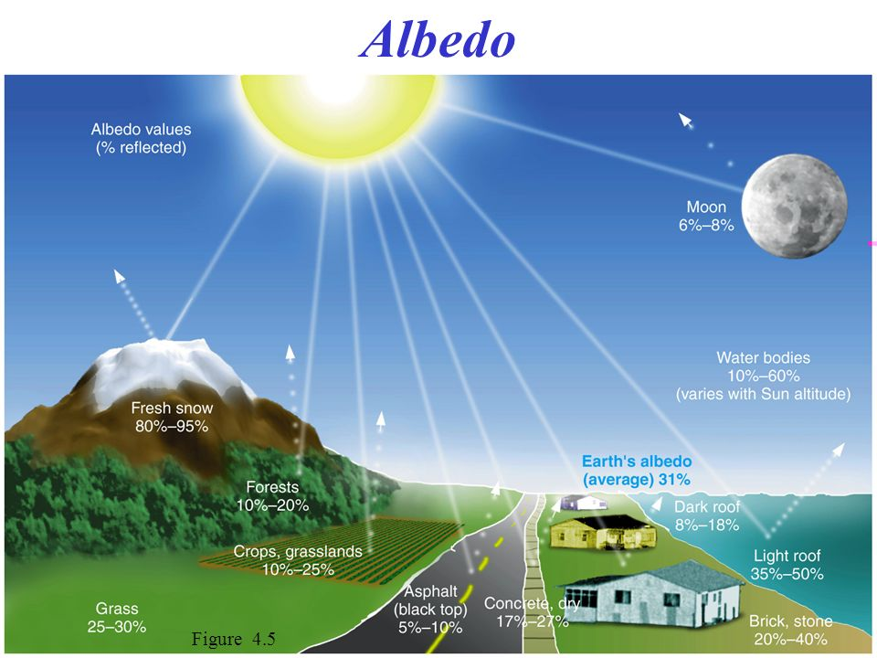
Color and texture combine to create differing amounts of reflectivity on Earth’s natural surfaces called ______________.
Snow can reflect up to ____________of incoming solar energy (and absorb 5%) while Asphalt will reflect only ___________(and absorb 95%)
Making a connection: If glaciers continue to melt as global temperatures rise, how may that further contribute to a global temperature change?

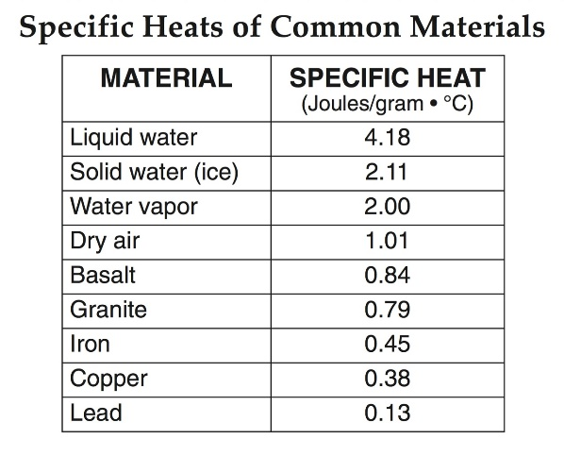
iii. The type of medium; differential heating according to specific heat (pg. 1 of ESRT)
- Specific Heat-

- It takes ________joules of energy to increase the temperature of water by ____________ but granitic rock (most continental crust) only _________joules
- The relationship: the _________________the specific heat of a substance, the ______________the resistance to heating
Conduction: ________________________________________________________________
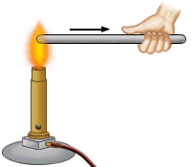
_________________________________________________________________________
The________________________ a molecule is the____________ it vibrates
- _____________________will only occur when two objects (or substances) have ______________________ (different temperatures)
- Heat will always transfer from the heat ______________ _________________to the heat _______ ______________
- If not all energy is gained by the “sink” it has been lost to the ____________________ (no transfer is 100% efficient!). All systems lose some heat energy during _______________.
Examples:
Convection: __________________________________________________________________
___________________________________________________________________________
- Warm substances: are _____________________than their cooler counterparts. This is because as a substance warms, the volume of the substance____________________, due to the molecules moving ___________________from one another. Lower density means the substance will_________________.
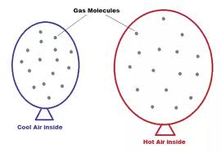
Cooler substances: are _____________________ than their warmer counterparts. This is because as a substance cools, the volume of the substance _________________, due to the molecules moving ____________ ____________________.Higher density means the substance will __________________.
Draw a diagram of the demo you saw in class below: Include labels such as warm, less dense, rises, cool, denser, sinks, with arrows to show what is going on.

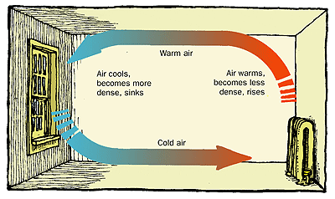

Why do you feel drafts?

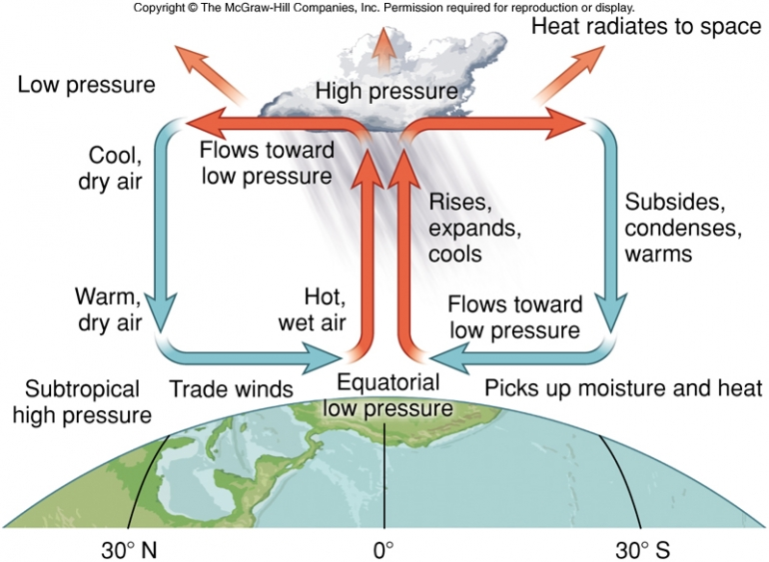
Convection in the Atmosphere:
*On Earth, warm air _____________and cool air __________________.
*Warmer air is _______________ dense, and creates regions of _____________________________ on earth
*Cooler air is ___________________dense and creates regions of __________________________

The Greenhouse Effect
Earth’s surface absorbs incoming short-waved __________________ and _______________________ radiation as well as incoming long-wave ______________________ from the Sun. Once energy is absorbed, earth re-radiates this energy in the form of only long wave ___________________ energy. If it weren’t for greenhouse gases, the earth’s average temperature would be below ______________. An increase in greenhouse gases will cause global temperature averages to continue to _______________, as __________ of earth’s outgoing______________ ___________________ radiation becomes trapped by our atmosphere.
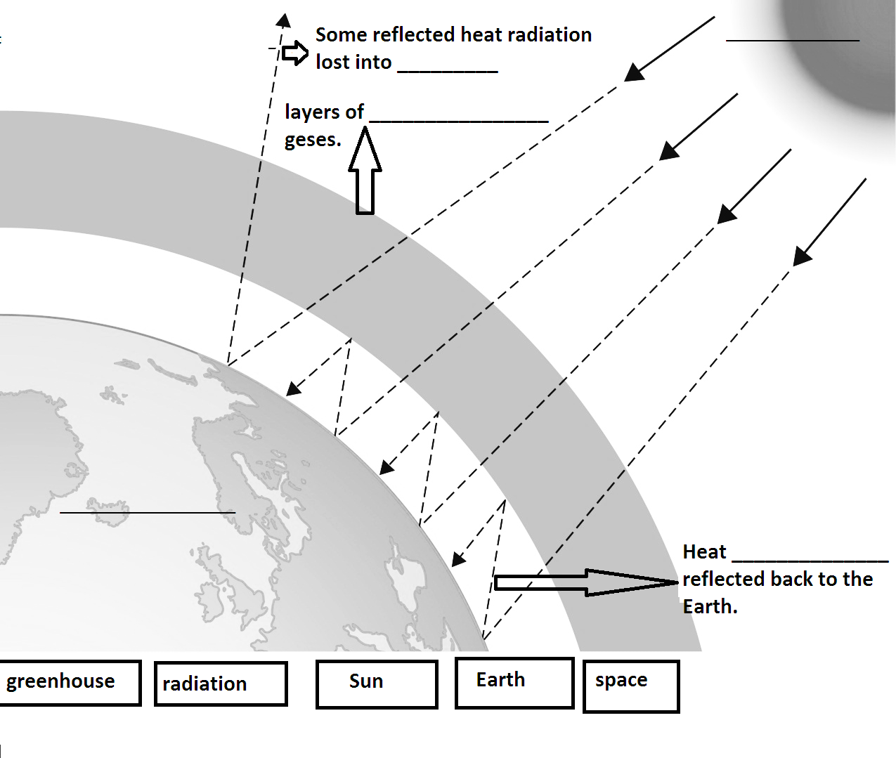Greenhouse gases:

